C++ Project

**Topic :-**

***Hotel Management System***

### THIS PROJECT IS DEVELOPED BY:

**NAME : Ayush Jaiswal**

**CLASS : XII**

**SESSION : 2015-16**

Objective

This program is written so that it becomes easy for the authorities of any hotel or inn to effortlessly be able to manage the information of all their customers.

This program is written in such a user friendly manner, that managing all the data will not be a problem at all.

It will be easy for the front office personnel, to keep a track on the hotel room booking. This will also help the marketing team to keep the customer’s data .

Software USED

* TURBO C++ VERSION0.74.0.0
* DOS BOX

HARDWARE USED

* LAPTOP
* PC
* PRINTER
* PEN DRIVES

ADVANTAGES

* THE PROGRAM IS SUITABLE FOR VARIOUS TYPES OF HOTELS WHERE RECORDING AS WELL AS DELETION OF CUSTOMER INFORMATION IS NECESSARY.
* THE PROGRAM IS EASY TO UNDERSTAND AND USE.

DISADVANTAGES

* ALL AVAILABLE C++ CONCEPTS ARE NOT APPLIED IN THE PROGRAM.
* THE PROGRAM DOES NOT ALLOW THE USER TO CALCULATE THE BILLS TO BE PAID BY ALOTEES.

PROJECT MANUAL

**STEPS TO RUN THE PROGRAM :-**

**i)** Place the CD in the CD Drive of a desktop and insert the disk.

**ii)**Open My Computer and copy folder – **HOTEL MANAGEMENT**.

**iii)** Save the folder - **HOTEL MANAGEMENT** in the desktop.

**iii)** When the file has been saved open the folder - **HOTEL MANAGEMENT.**

**iv)** Double on the file **HOTEL.exe** and the program will start to run.

**v)**  Proceed according to the program.

SOURCE CODE

#include<conio.h>

#include<fstream.h>

#include<stdio.h>

class hotel

{

introom_no;

char name[30];

char address[50];

char phone[10];

public:

voidmain_menu(); //to dispay the main menu

void add(); //to book a room

void display(); //to display the customer record

void rooms(); //to display alloted rooms

void edit(); //to edit the customer record

int check(int); //to check room status

void modify(int); //to modify the record

voiddelete_rec(int); //to delete the record

};

void hotel::main_menu()

{

int choice;

while(choice!=5)

{

clrscr();

cout<<"\n\t\t\t\t*************";

cout<<"\n\t\t\t\t* MAIN MENU *";

cout<<"\n\t\t\t\t*************";

cout<<"\n\n\n\t\t\t1.Book A Room";

cout<<"\n\t\t\t2.Customer Record";

cout<<"\n\t\t\t3.Rooms Allotted";

cout<<"\n\t\t\t4.Edit Record";

cout<<"\n\t\t\t5.Exit";

cout<<"\n\n\t\t\tEnter Your Choice:";

cin>>choice;

switch(choice)

{

case 1: add();

break;

case 2: display();

break;

case 3: rooms();

break;

case 4: edit();

break;

case 5:break;

default:

{

cout<<"\n\n\t\t\tWrong choice…..!!!";

cout<<"\n\t\t\tPress any key to continue.!!";

getch();

}

}

}

}

void hotel::add()

{

clrscr();

intr,flag;

fstreamfout("Record.dat",ios::app);

cout<<"\n Enter Customer Detalis";

cout<<"\n ";

cout<<"\n\n Room no: ";

cin>>r;

flag=check(r);

if(flag)

cout<<"\n Sorry..!!!Room is already booked";

else

{

room_no=r;

cout<<" Name: ";

gets(name);

cout<<" Address: ";

gets(address);

cout<<" Phone No: ";

gets(phone);

fout.write((char*)this,sizeof(hotel));

cout<<"\n Room is booked!!!";

}

cout<<"\n Press any key to continue..!!";

getch();

fout.close();

}

void hotel::display()

{

clrscr();

ifstream fin("Record.dat",ios::in);

intr,flag;

cout<<"\n Enter room no: ";

cin>>r;

while(fin.read((char*)this,sizeof(hotel)))

{

if(room_no==r)

{

clrscr();

cout<<"\n Customer Details";

cout<<"\n";

cout<<"\n\n Room no: "<<room_no;

cout<<"\n Name: "<<name;

cout<<"\n Address: "<<address;

cout<<"\n Phone no: "<<phone;

flag=1;

break;

}

}

if(flag==0)

cout<<"\n Sorry Room no. not found or vacant.!!";

cout<<"\n\n Press any key to continue.!!";

getch();

fin.close();

}

void hotel::rooms()

{

clrscr();

ifstream fin("Record.dat",ios::in);

cout<<"\n\t\t\t List Of Rooms Allotted";

cout<<"\n\t\t\t";

cout<<"\n\n Room No.\tName\t\tAddress\t\tPhone No.";

while(!fin.eof())

{

fin.read((char*)this,sizeof(hotel));

cout<<"\n\n "<<room_no<<"\t\t"<<name;

cout<<"\t\t"<<address<<"\t\t"<<phone;

}

cout<<"\n\n\n\t\t\tPress any key to continue..!!";

getch();

fin.close();

}

void hotel::edit()

{

clrscr();

intchoice,r;

cout<<"\n EDIT MENU";

cout<<"\n ";

cout<<"\n\n 1.Modify Customer Record";

cout<<"\n 2.Delete Customer Record";

cout<<"\n Enter your choice: ";

cin>>choice;

clrscr();

cout<<"\n Enter room no: " ;

cin>>r;

switch(choice)

{

case 1: modify(r);

break;

case 2: delete_rec(r);

break;

default: cout<<"\n Wrong Choice..!!";

}

cout<<"\n Press any key to continue.!!!";

getch();

}

int hotel::check(int r)

{

int flag=0;

ifstream fin("Record.dat",ios::in);

while(!fin.eof())

{

fin.read((char*)this,sizeof(hotel));

if(room_no==r)

{

flag=1;

break;

}

}

fin.close();

return(flag);

}

void hotel::modify(int r)

{

longpos,flag=0;

fstream file("Record.dat",ios::in|ios::out|ios::binary);

while(!file.eof())

{

pos=file.tellg();

file.read((char*)this,sizeof(hotel));

if(room_no==r)

{

cout<<"\n Enter New Details";

cout<<"\n";

cout<<"\n Name: ";

gets(name);

cout<<"Address:";

gets(address);

cout<<" Phone no: ";

gets(phone);

file.seekg(pos);

file.write((char*)this,sizeof(hotel));

cout<<"\n Record is modified.!!";

flag=1;

break;

}

}

if(flag==0)

cout<<"\n Sorry Room no. not found or vacant!!";

file.close();

}

void hotel::delete_rec(int r)

{

int flag=0;

charch;

ifstream fin("Record.dat",ios::in);

ofstreamfout("temp.dat",ios::out);

while(!fin.eof())

{

fin.read((char*)this,sizeof(hotel));

if(room_no==r)

{

cout<<"\n Name: "<<name;

cout<<"\n Address: "<<address;

cout<<"\n Pone No: "<<phone;

cout<<"\n\n Do you want to delete this record(y/n): ";

cin>>ch;

if(ch=='n')

fout.write((char*)this,sizeof(hotel));

flag=1;

}

else

fout.write((char*)this,sizeof(hotel));

}

fin.close();

fout.close();

if(flag==0)

cout<<"\n Sorry room no. not found or vacant...!!";

else

{

remove("Record.dat");

rename("temp.dat","Record.dat");

}

}

void main()

{

clrscr();

hotel h;

cout<<"\n\n\n\n\n\n\n\t\t\tThis Project is Made by:";

cout<<"\n\t\t\tAyushJaiswal";

cout<<"\n\t\t\tSarbojoy Das";

cout<<"\n\t\t\tArunavaModak";

cout<<"\n\t\t\tDebjitMondal";

cout<<"\n\n\n\n\n\n\n\t\t\tPress any key to continue.!!";

getch();

h.main_menu();

}

POSSIBLE OUTPUTS

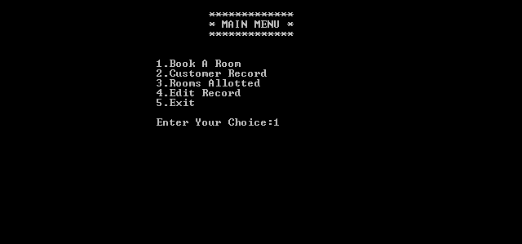

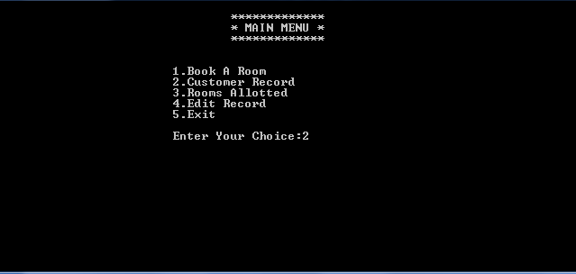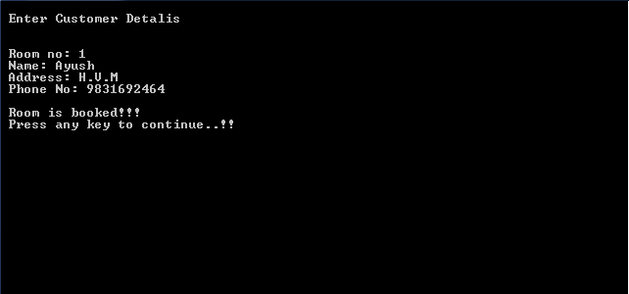

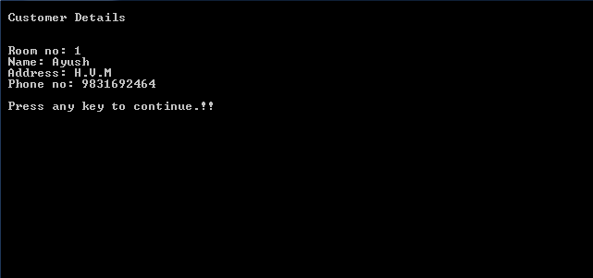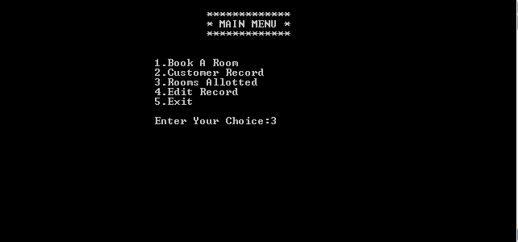

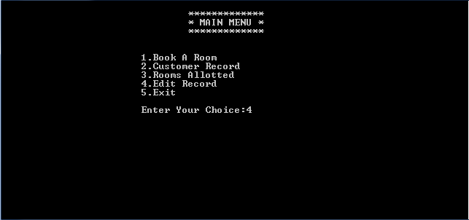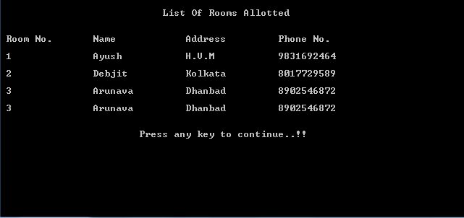

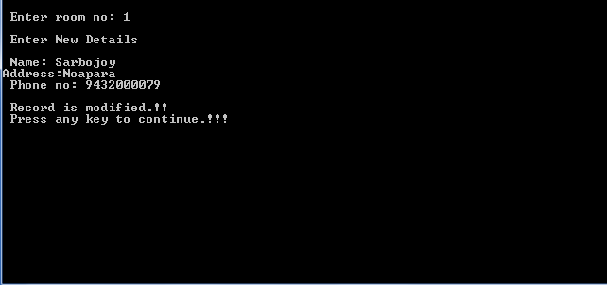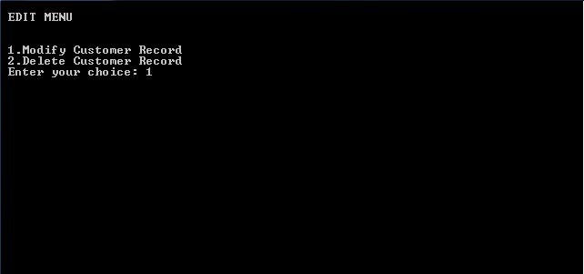

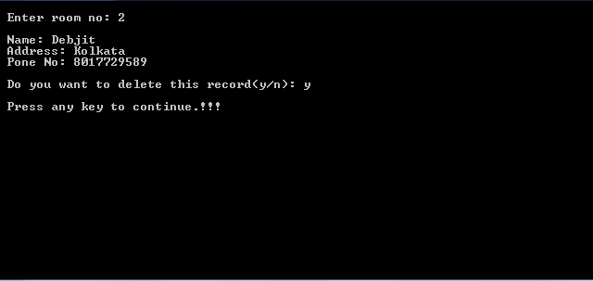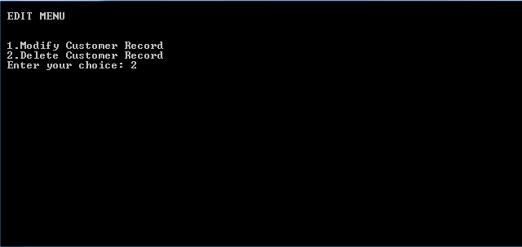

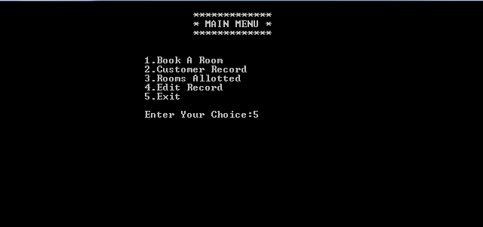

BiblioGRAPHY

The following books have been used to develop the program :-

i) Computer Science with C++ for Class XII bySumitaArora.

ii) Object Oriented Programming E. Balagurusamy.

iii) C++ by Yashwant P. Kanetkar.

The following sites have been very useful in developing the program :-

i) codeacademy.com

ii)w3schools.com

iii)codesworld.com